Skyn Data Manager (SDM)
Instructional Manual

Status… Experimental testing
SDM Version… v1.6.3
OS compatibility… Windows 10
Skyn firmware compatibility… 2.0.8
Manual Last updated… 9.2.24
For help or to report bugs… email nathan_didier@brown.edu

Table of Contents
Page 2… SDM Functions
Page 3… Downloading SDM
Page 3-4… Running SDM
Page 8… Data Requirements
Page 9… Metadata Requirements
Page 10… Replicating Development Environment

SDM Functions
File Configuration
- Configures Skyn dataset filenames with metadata
- File splitting tool for converting multi-day datasets into separate Excel files
Signal processing
- Low quality datasets can be filtered out using user-determined criteria
- Datasets can be cropped according to user-designated durations/times
- Imputes gaps in data (due to device removal or device off), artifacts, and noise
- Provides temperature visualization and detection of potential non-wear
Feature engineering
- For each Skyn dataset, the SDM will calculate
  - TAC descriptors: Peak, TAC-AUC, Rise Duration, Fall Duration, Rise Rate, Fall Rate, and several others features.
  - Quality descriptors: Percent/duration of device removal, artifacts, etc.
Make Predictions on New Data using Built-In Models
- A random forest model and logistic regression model can be used to make predictions of whether or not a single Skyn dataset corresponds to alcohol consumption
- Model was trained & tested using group k-fold cross validation with 30 alcohol episodes and 30 non-alcohol episodes.
- Random forest and logistic regression achieved accuracy of 97% (58/60)
Train and Make Predictions with New Models using New Data
- 2 models are trained: random forest and logistic regression
- Models are trained in two ways: using features from cleaned (processed) data and using features from raw (unprocessed) data
- Altogether, 4 models will be trained and tested
Automated Excel Workbooks and Reports
- Each individual dataset will saved as an Excel file that includes 3 tabs:
  - Processed Skyn datasets will be saved with new columns for cleaned & smoothed data
  - Variable key that defines the column names
  - Graphs to visualize the raw versus cleaned data, temperature, etc.
- Whole-cohort analysis will produce an Excel file that includes several tabs for:
  - Feature data
  - Model prediction results
  - Compiled visual summary of each Skyn dataset.
- Several graphs summarizing the models

Download Software
Follow instructions here: https://github.com/ndidier3/skyn_data_manager/releases
Running the Software
Step 1: Double click the SDM.exe file within the skyn_data_manager folder. The user interface may take a minute or more to appear.
First time running? Check out the File and Resource dropdowns…
- File includes a File Splitting Tool (slicing a long file into several files) and a Create Metadata Tool.
- Resources includes information about citing, documentation, and variable descriptions.
Step 2: Select data loading method.
- To conduct a quick test to make sure the software is setup and can be used on your computer, select the last option.
- To load a whole cohort of data, select the top option. After SDM processes a whole cohort, it will export the associated data and/or models within a .pickle file.
  - If you split a file using the File Splitting Tool, select the Split_Files folder where all the separated data sets exist.
- To load only a single file, select the second option.
- The third option is for loading a .sdm file, i.e., an already-processed cohort that was generated previously by the SDM.
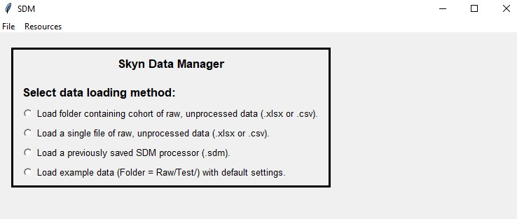

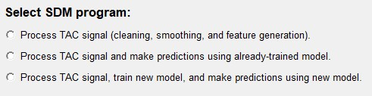
Step 3: Select SDM program. Depending on the data loading method, SDM may display different settings or options.

Step 4. Fill in Cohort Name and Select Data.
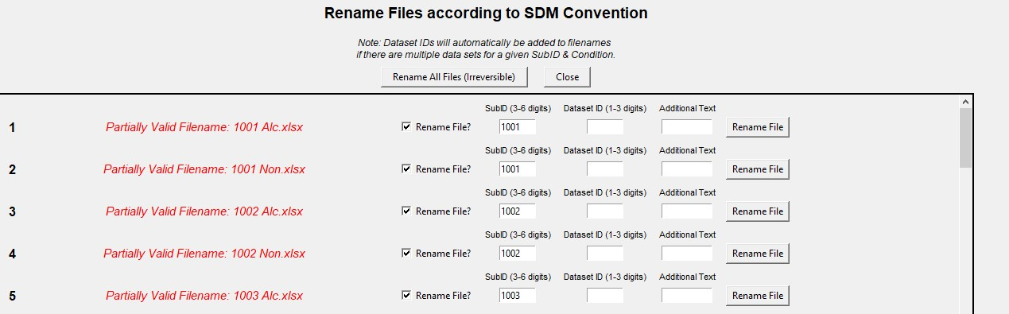
If filename(s) of the selected data are not compatible with SDM, you will be prompted to correct the filenames using SDM’s built-in file renaming tool.

Step 5. Select metadata. If no metadata file has been created, you can create one by clicking “Create Metadata File” under File header. Or, you can let SDM run without metadata.
Step 6. Click “Submit”
Step 7. Customize settings as needed. If unsure, use defaults. When ready, click “Launch SDM”.
Note: The SDM window will freeze when the program is running.
Inputs Folder
The Inputs folder includes Excel files of Metadata, Skyn Data, and other Excel documents that may be helpful to have on hand.
- The Skyn_Data subfolder is designated to house folders of raw Skyn data. Each folder stored within Skyn_Data should contain only .csv or .xlsx files.
- The Metadata subfolder is used to store metadata files that provide configuration information about a respective cohort of Skyn data.
  - A metadata file is required to run SDM.
  - Column headers must include SubID, Condition, Dataset_Identifier, Episode_Identifier, Use_Data, and TotalDrks
  - This file can be created manually in Excel or you can use the SDM “Create Metadata” which is found in the Tools header
  - To exclude a dataset from analyses, label the row with “N” in the Use_Data column.
  - Optional: Fill in TotalDrks column to indicate the # of drinks consumed for that episode. AUD, sex, are also optional. Any additional columns can be added to the right, as needed.
  - Optional: If you have timestamps to indicate the beginning/end of drinking episodes, fill in the columns Time Zone, Crop Begin Date, Crop Begin Time, Crop End Date, and Crop End Time. Use the following formatting:
    - Dates: month/day/year (5/25/2023)
    - Use military time (HH:MM:SS)

Replicating Development Environment
- Download git:
- If on Windows, download from here Git - Downloads (git-scm.com)
- If on Mac, enter these 3 commands into the terminal:
  - /bin/bash -c "$(curl -fsSL https://raw.githubusercontent.com/Homebrew/install/HEAD/install.sh)"
  - brew update
  - brew install git
- Download Anaconda or MiniConda: Anaconda | The World’s Most Popular Data Science Platform
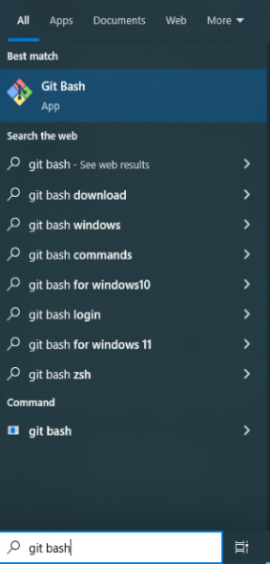
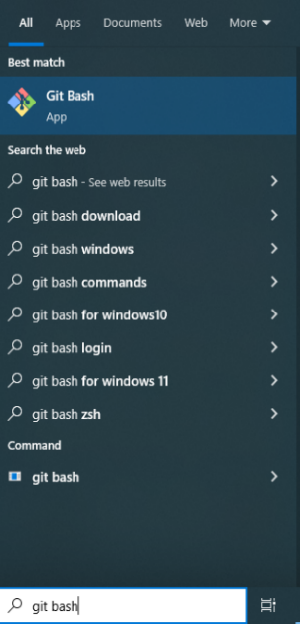
  - This is a software package that includes Python so SDM can run. It also includes several IDEs such as VS Code – these are helpful if you would like to view or edit the code.
- Open git bash (if on Windows) or terminal (if on Mac)
- Navigate to the folder you would like to store the SDM:
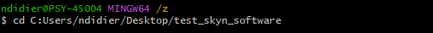
cd <path to folder>
- Download SDM:
git clone https://github.com/ndidier3/skyn_data_manager.git
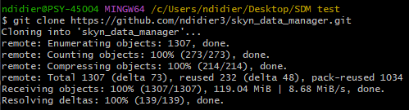

- Check that folder looks like this:
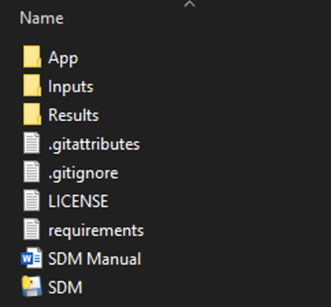
  - App/ is where the software code exists
  - Inputs/Skyn_Data is where raw Skyn data will be stored
  - Inputs/Metadata is where metadata will be stored
  - Results is where SDM output will go
Launch the app
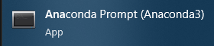
- Open Anaconda Prompt (Windows) or terminal (Mac)
- Go to SDM folder with command:
  - cd <path-to-folder>
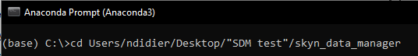

- If first time using SDM, run these below commands. Enter ‘y’ if commands have follow up questions. Some of these installs may take a few minutes.
conda deactivate
conda create -n sdm-env python=3.8.8
conda activate sdm-env
conda install --file requirements.txt
conda install -c conda-forge kneed=0.7.0
conda install -c conda-forge scikit-learn=1.3.0
    - this may take 10+ minutes, not because it takes up a lot of storage, but because Anaconda is creating compatibility between this package and all the other packages
- Launch SDM using commands:
conda activate sdm-env
python App/sdm_user_interface.py

